NB-200A

3-jaw extra large through-hole power chuck (adapter included)
- More large bore:
The largest bore in wedge type power operated chucks.
- 20% large bore:
Approximately 20% higher speed, higher gripping force and larger bore compared with regular chucks.
- Model NB-200A chucks are assembled with adaptor for ASA B5.9 type A spindles.
- Model NB-200A chucks are manufactured form high grade alloy steel. All sliding surfaces are hardened and ground for accurate actual running and long service repeatability.
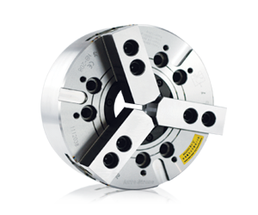
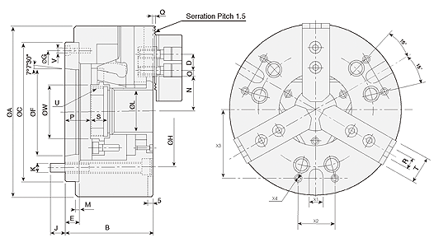
UNIT : mm
SPEC  Model | Through  -Hole  (mm) | Plunger  Stroke  (mm) | Jaw  Stroke  (In Dia.)  (mm) | Max.  Pull  Force  (kgf) | Max.  Gripping  Force  (kgf) | Max.  Operating  Pressure  (kgf / cm²) | Max.  Speed  (r.p.m.) | Weight  (kg) | Moment  Of Inertia I  (kg‧m² ) | Matching  Cylinder | Matching  Hard Jaw | Matching  Soft Jaw | Gripping  O.D. Range  (mm)
NB-306A5 | Ø52 | 12 | 5.4 | 2243 | 5812 | 18.4 | 6000 | 14 | 0.06 | M1552 | HJ06 | HC06 | Ø16-Ø170
NB-208A6 | Ø66 | 16 | 7.4 | 3558 | 9075 | 20.5 | 5000 | 24 | 0.14 | M1868 | HJ08 | HC08 | Ø20-Ø210
NB-210A8 | Ø78 | 19 | 8.8 | 4385 | 11319 | 27.5 | 4200 | 37.4 | 0.4 | M1878 | HJ10 | HC10 | Ø25-Ø254
NB-310A8 | Ø81 | 19 | 8.8 | 4976 | 12848 | 31.5 | 4500 | 36.4 | 0.33 | MK1881 | HJ10 | HC10 | Ø37-Ø254
NB-212A11 | Ø122 | 23 | 10.6 | 5812 | 14990 | 20.5 | 3200 | 65 | 0.95 | M2511 | HJ12 | HC12 | Ø41-Ø315
NB-215A15 | Ø142 | 23 | 10.6 | 7240 | 18355 | 25.5 | 2500 | 130 | 3.0 | M2816 | HJ15 | HC15 | Ø60-Ø405
NB-218A15 | Ø166.5 | 23 | 10.6 | 7240 | 18355 | 25.5 | 2000 | 161 | 4.77 | M2816 | HJ15 | HC15 | Ø75-Ø457

DIM  Model | A | B | C  (H6) | D | E | F | G | H | J | K | L | M | N  max. | O  max. | O  min. | P  max. | P  min. | Q | R | S | T | U  max. | V | W | X  (H12) | X2 | X3 | X4
NB-306A5 | 170 | 91 | 140 | 20 | 15 | 82.563 | 116 | 104.78 | 14.5 | 6xM10 | 52 | 5 | 34.3 | 18.25 | 9.25 | 26 | 14 | 2 | 12 | 20 | 31 | M60x2 | 3xM6 | 65 | 16 | 36 | 65 | M8
NB-208A6 | 210 | 103 | 170 | 25 | 17 | 106.375 | 150 | 133.35 | 19.5 | 6xM12 | 66 | 5 | 42 | 23.75 | 11.75 | 31.5 | 15.5 | 2 | 14 | 20 | 35 | M74x2 | 3xM6 | 80 | 16 | 45 | 80 | M8
NB-210A8 | 254 | 113 | 220 | 30 | 18 | 139.719 | 190 | 171.45 | 24 | 6xM16 | 78 | 5 | 53 | 33.75 | 14.25 | 26.5 | 7.5 | 2 | 16 | 25 | 40 | M87x2 | 3xM8 | 94 | 16 | 60 | 102 | M10
NB-310A8 | 254 | 113 | 220 | 30 | 18 | 139.719 | 190 | 171.45 | 24 | 6xM16 | 81 | 5 | 54 | 32.25 | 14.25 | 26.5 | 7.5 | 2 | 16 | 25 | 40 | M90x2 | 3xM8 | 97 | 16 | 60 | 102 | M10
NB-212A11 | 315 | 134 | 300 | 30 | 22 | 196.869 | 260 | 235 | 28 | 6xM20 | 122 | 6 | 74.2 | 36.25 | 12.75 | 42 | 19 | 2 | 21 | 28 | 50 | M135x2 | 3xM10 | 143 | 20 | 60 | 138 | M10
NB-215A15 | 405 | 154 | 380 | 43 | 27 | 285.775 | 330.2 | 330.2 | 33 | 6xM24 | 142 | 6 | 93.5 | 45.25 | 15.25 | 34 | 11 | 5 | 22 | 43 | 62 | M155x2 | 3xM12 | 164 | 20 | 80 | 160 | M12
NB-218A15 | 457 | 154 | 380 | 43 | 27 | 285.775 | 330.2 | 330.2 | 33 | 6xM24 | 166.5 | 6 | 96.7 | 63.25 | 18.25 | 34 | 11 | 5 | 22 | 43 | 62 | M180x3 | 3xM12 | 189 | 20 | 100 | 160 | M12

